**10: Frontend Application - Create Deployment and NodePort Service**

--- **Reference** - <https://github.com/stacksimplify/kubernetes-fundamentals/tree/master/10-Services-with-YAML/kube-manifests>

--- in this lecture we will focus on frontend.

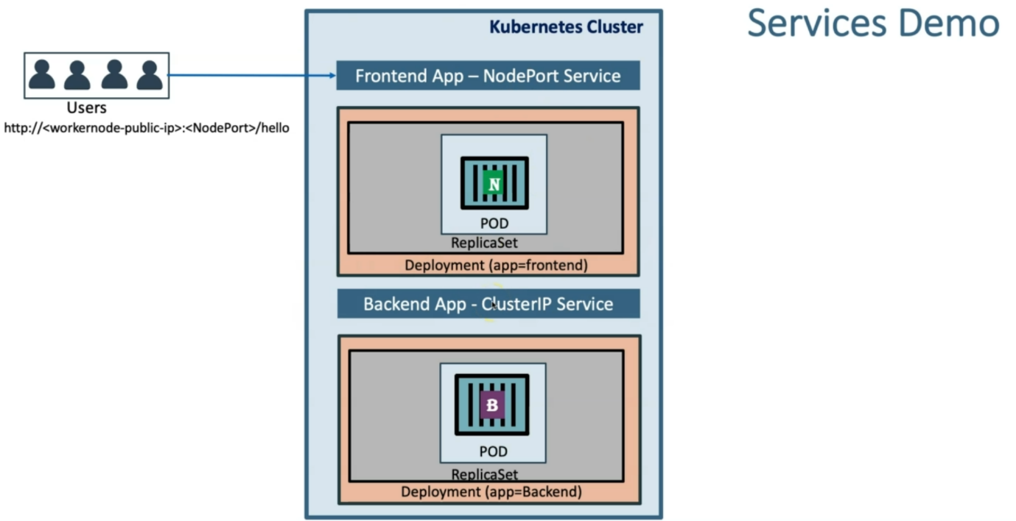

**Create Frontend Deployment & NodePort Service**

--- **Write the Deployment template for frontend Nginx Application**

apiVersion: apps/v1

kind: Deployment

metadata:

  name: frontend-nginxapp

  labels:

    app: frontend-nginxapp

    tier: frontend

spec:

  replicas: 3

  selector:

    matchLabels:

      app: frontend-nginxapp

  template:

    metadata:

      labels:

        app: frontend-nginxapp

        tier: frontend

    spec:

      containers:

        - name: frontend-nginxapp

          image: stacksimplify/kube-frontend-nginx:1.0.0

          ports:

            - containerPort: 80

--- **Write the NodePort service template for frontend Nginx Application**

apiVersion: v1

kind: Service

metadata:

  name: frontend-nginxapp-nodeport-service

  labels:

    app: frontend-nginxapp

    tier: frontend

spec:

  type: NodePort

  selector:

    app: frontend-nginxapp

  ports:

    - name: http

      port: 80

      targetPort: 80

      nodePort: 31234

--- **cd <Course-Repo>\kubernetes-fundamentals\10-Services-with-YAML\kube-manifests**

--- **kubectl get all**

--- **kubectl apply -f 03-frontend-deployment.yml -f 04-frontend-nodeport-service.yml**

--- **kubectl get all**

--- **kubectl get pods** – to list the pods.

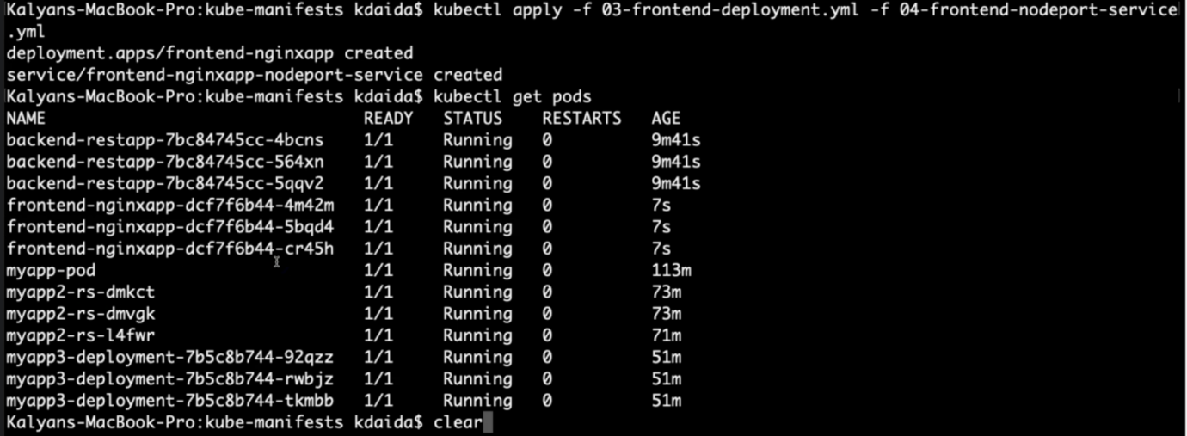

--- **note** – it created 3 frontend pods.

--- **kubectl get svc** – to list the service

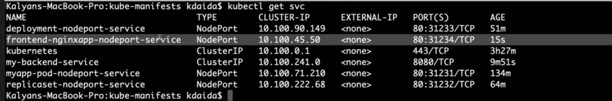

--- **note** – our frontend nodeport service got created.

**Access REST Application**

**# Get External IP of nodes using**

--- **kubectl get nodes -o wide**

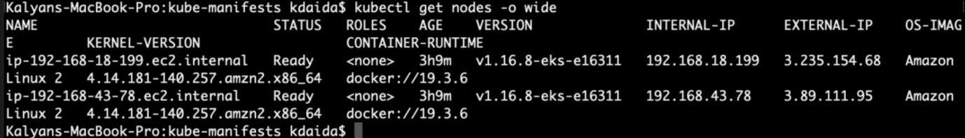

--- **note** – take the ip under the external ip section.

**# Access REST Application (Port is static 31234 configured in frontend service template)**

--- **http://<node1-public-ip>:31234/hello**